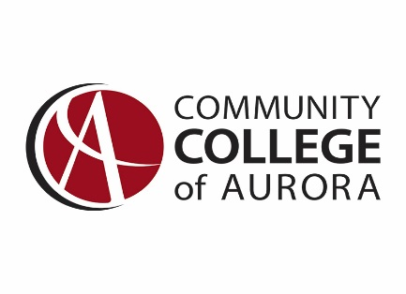

Workstudy Job Description Announcement

Job Title | Lab-Tech
Department | Film/Video Media (FVM)
Campus & Location | Lowry Campus, Colorado Film School, 9075 E. Lowry Blvd.
Supervisor | Aaron Koehler Email: Aaron.Koehler@ccaurora.edu (No phone calls please)  James Tharp (Proxy) Email: James.Tharp@ccaurora.edu (303.340.7322)

General Description
Assist supervisor, department head, staff and faculty with all equipment cage services and film school operations.
Duties & Responsibilities
- General Customer Service – Assist guests, students, staff, and faculty with equipment and technology needs in the building. This includes: answering the Cage phone, responding to questions about equipment and/or technology, equipment check-ins & check-outs.
- Complete equipment check-ins & check-outs for students, staff, and faculty- Ensuring that all Safety Guidelines as approved by CCA are in-place, and in-practice.
- Assist in maintaining order and safety of CFS facilities, to include (but not limited to): the studio, computer labs, classrooms, equipment bays, and equipment cage.
- Assist with equipment inventory
- Assist with equipment repairs
- Barcode / Label / and Organize equipment and equipment packages.
- Training Video Production & Post Production.
- Assist with CFS special events.
- Assist with testing and development of equipment check-out platform (FSGreenlight)
- Equipment training and certifications
Qualifications/Requirements
- Must be willing to come to campus at least 5hrs/week
- Positive attitude and willingness to learn
- This job entails a combination of various physical activity and may include extended periods of standing, sitting, kneeling, and/or bending.
- Additional physical demands of the job include: lifting (up to 50lbs), working with ladders, and electrical tools.
- Must have strong communication skills
- This position may be required to work occasional special events to include evenings and off-hours.
- Attention to detail, along with a friendly, and pleasant demeanor is a must.

Number of Hours per Week: 10-20

